Tech Tip
BLUE BIRD VISION
POWERED by ROUSH PROPANE

From your friends at New York Bus Sales
Air Compressor Coolant Lines Rubbing

Complaint - There is a coolant leak at the left front of the engine compartment

Cause - Coolant lines to the air compressor appear to be leaking

Correction - Looking above where the leak is the area in question is shown on FIGURE #1 you can see that there are 2 hoses which are wrapped in spit loom and run along the frame rail as shown in FIGURE #2. There are several options which we are all aware of to address this such as putting a section of hose on the frame rail or putting a larger hose over the loom. As you can see in FIGURE #3 we have tied the hoses back with a zip-tie which is another option. Since finding this issue, we have found that Blue Bird is routing the hoses differently and that is shown in FIGURE #4.

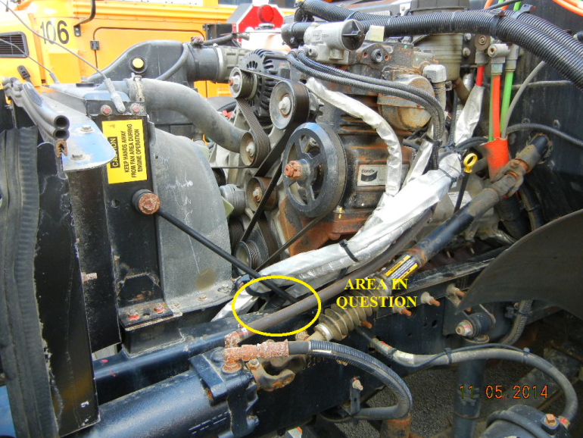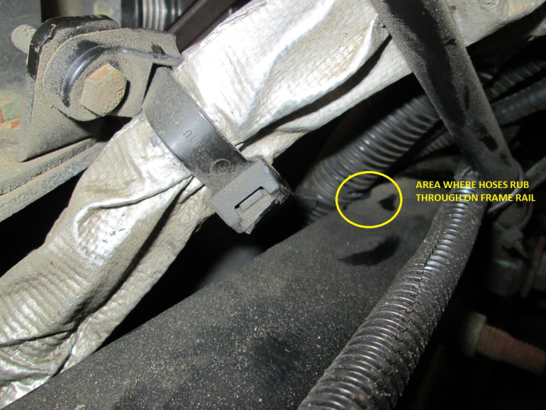
FIGURE #1 FIGURE #2

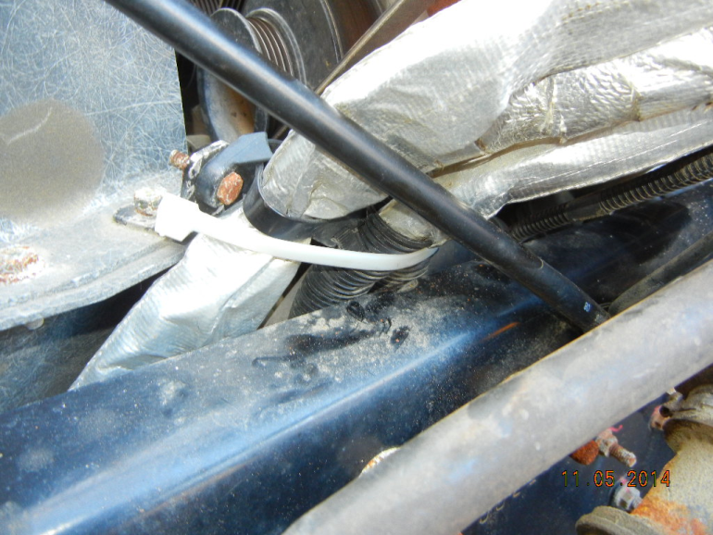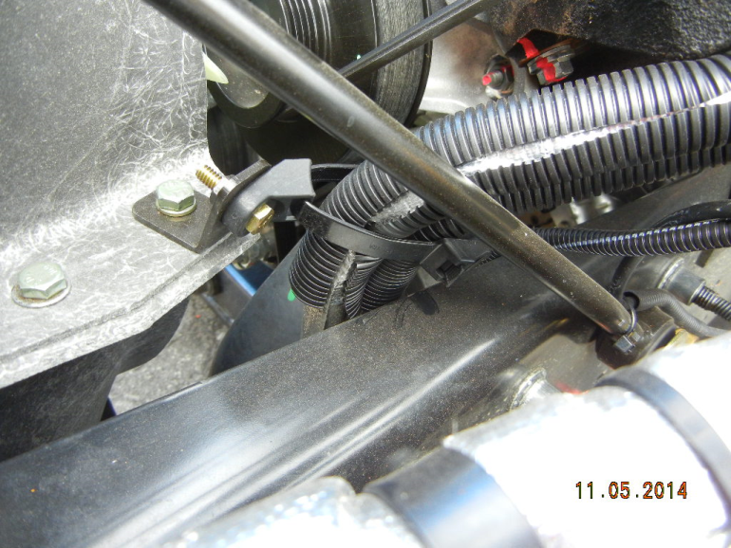
FIGURE #3 FIGURE #4

Contact Our Service Department With Any Questions
CHITTENANGO – phone 800-962-5768 or
Daryl Wallace : dwallace@newyorkbussales.com
Brian Lamaitis : blamaitis@newyorkbussales.com

ROCHESTER – phone 800-463-3232 or
Gary Chichester: gchichester@newyorkbussales.com

ALBANY – phone 866-867-1100 or
Ben Reiling: breiling@newyorkbussales.com

WARRANTY – 800-962-5768 ext 237
Morgan Jenkins: mjenkins@newyorkbussales.com

PLEASE ALSO NOTE OUR NEW CUSTOMER SUPPORT REPRESENTATIVES
EAST
Gary Bigness: gbigness@newyorkbussales.com
Cell 845-500-3707
CENTRAL
JJ Richmond: jrichmond@newyorkbussales.com
Cell 315-559-3999
WEST
Mike Panzica: mpanzica@newyorkbussales.com
Cell 716-908-3186

Thanks to our man Steve at Whitney Point Central School for pointing this out!

