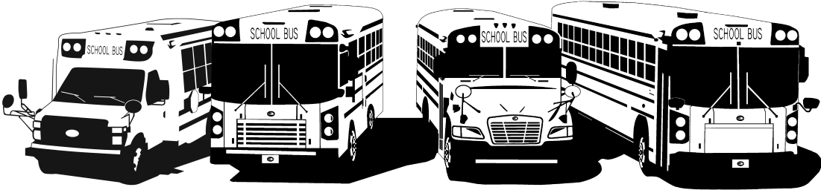
FROM YOUR FRIENDS AT NEW YORK BUS SALES!

Webasto Training Notes
Earlier this week New York Bus Sales hosted training across the state and if you were not able to attend we wanted to pass along some key points from the training for those who could not attend!
Webasto offers ALL their service manuals and technical information through a secure website-
http://www.techwebasto.com/
When you enter the site, click on the “register” button in the upper right corner as shown in Figure #1 and you will be taken to a registration page as shown in Figure #2. When registering use your company or school name followed by “/New York Bus Sales” and you will get a verifying e-mail that you are set to use the site.
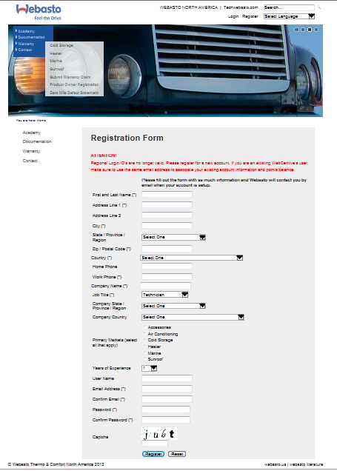
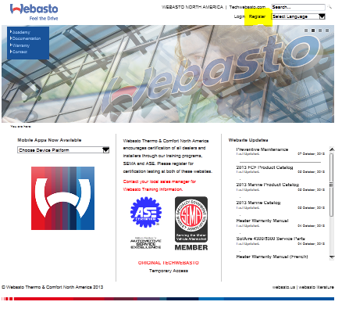
Figure #1 Figure #2

IMPORTANT NOTES
- When checking temperatures of fluid entering the heater and leaving the heater there should be no than a 20*-25* Δδ (delta/change)
- Reflector Plate – MUST be flat
- Photo Eye – Not scratched or chipped
- Clutch Coupler – ALWAYS replace in pairs PART #350516
- ALWAYS make sure the Grommets are present-LEFT PART #298964/RIGHT PART #299995
- DO NOT clean grease from the drive gear/combustion air fan gears-It is special grease rated for -100* to 300*
- WIRE COLORS
- BROWN – GROUND
- RED – HOT
- BLACK – TURNS SOMETHING ON
- WRITING ON THE UNIT
- RED – 12 VOLT
- GREEN – 24 VOLT
- 6 PIN Connector
- Pins 1-2 white/white – Overheat Fuse
- Pins 3-4 green/green – Temperature Limiter
- Pins 5-6 green/red – Control Thermostat
- If you have a unit which will not fire in the cold but once in the shop fires and runs…..check the coil – Most Likely it is bad and you should look for a “DOT” in the potting material
GAPPING TOOL PART # 310646 $4.29
NEW TEST BOX PART #50440280A $308.98
OVERHEAT FUSE #406287 $23.44
AUTO RESET THERMOSTAT $18.75

MAINTENANCE
- EVERY MONTH – Run unit for 20 Minutes
- ANNUALLY – Replace nozzle/PART #88641A, Fuel Filter, Gap Electrodes/PART #1303871A, Clean Burner Tube, Clean Photo Eye/Reflector Plate and check seal/PART #378232
- When Fuel Filter is replaced – FILL the new filter with fuel
- Clean the housing with JUST a wire brush-No Cleaning products needed
- When cleaning Photo Eye/Reflector plate NO NOT use petroleum products….Alcohol or Brake Clean is recommended
- When tightening electrodes after adjusting gap DO NOT overtighten the bolt holding them, just tighten until the electrodes do not move
- EVERY 4 YEARS – Replace Drive Unit/Combustion Air Fan bearing kit
- When installing new bearing kit – Torque nut by tightening until fan rubs THEN back-off by 1/8th turn – PART #378313

Contact Our Service Department With Any Questions
CHITTENANGO – phone 800-962-5768 or
Daryl Wallace : dwallace@newyorkbussales.com
Brian Lamaitis : blamaitis@newyorkbussales.com

ROCHESTER – phone 800-463-3232 or
Gary Chichester: gchichester@newyorkbussales.com

ALBANY – phone 866-867-1100 or
Ben Reiling: breiling@newyorkbussales.com

WARRANTY – 800-962-5768 ext 237
Morgan Jenkins: mjenkins@newyorkbussales.com

PLEASE ALSO NOTE OUR NEW CUSTOMER SUPPORT REPRESENTATIVES
EAST
Gary Bigness: gbigness@newyorkbussales.com
Cell 845-500-3707
CENTRAL
JJ Richmond: jrichmond@newyorkbussales.com
Cell 315-559-3999
WEST
Mike Panzica: mpanzica@newyorkbussales.com
Cell 716-908-3186
Parts Manager
Gari McQuade
gmcquade@newyorkbussales.com
Chittenango Facility
Bill Cox
bcox@newyorkbussales.com
Dave Grant
dgrant@newyorkbussales.com
Don Kipp
dkipp@newyorkbussales.com
Rochester Facility
Jeremy Pilot
jpilot@newyorkbussales.com
Ravena Facility
Sean Conway
sconway@newyorkbussales.com

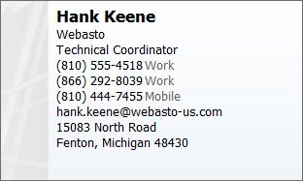
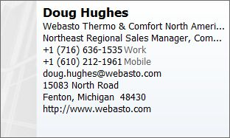
We’d like to thank Hank for providing GREAT technical training on the Webasto Scholastic Series Heater and his willingness to accept calls concerning issues on his cell phone at 810-444-7455

We are fortunate to have a rep from Webasto right here in New York State……PLEASE do not hesitate to call Doug if you have any questions or need information!

ALL of our Tech Tips can be found on the New York Bus Sales website at
http://www.newyorkbussales.com/pages/bulletins.cfm
Or at the New York Head Mechanic website at
www.nyhma.org

