***Tech Tip***

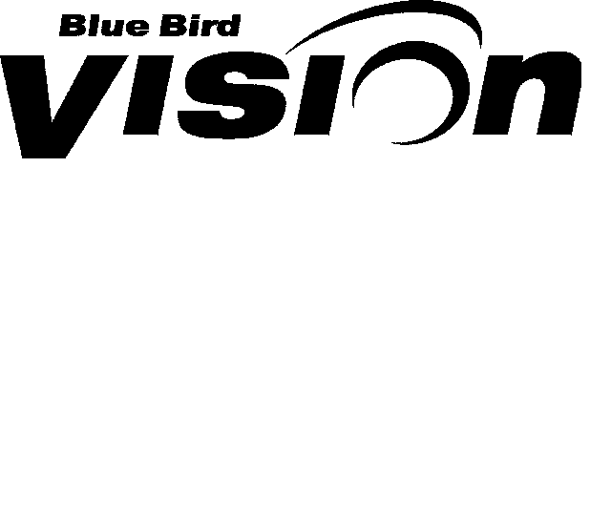 

***POWERED by PROPANE***

***From your friends at New York Bus Sales***

***Exhaust Wrap on manifold pipes of Roush Propane Units***

**Complaint - The “wrap” or “sock” installed on the manifold or “Y” pipes is torn and needs to be replaced -**

**Cause - There could be several causes – one thing that we have noticed with operators who have wash systems which include “undercarriage” washes may not be allowing the units to cool from runs and the sudden change in temperature cause the material to become more brittle and susceptible to breaking down from road debris hitting it-**

**PLEASE NOTE – The material used on this particular application has nothing to do with emissions, it is there primarily to provide added protection to surrounding components from heat!**

**Correction - Blue Bird engineering suggests to repair a small tear in the material that it be pulled pack together and 1 or 2 clamps be added to secure it.**

**UPDATE – 9/17/2013**

**Working with Blue Bird/Roush engineering it has been determined that the sock must in fact be in place, but to prevent damage to the wrap they have said that the sock can be wrapped over with part #01444009 (FIGURE #1) and secured with 2 clamps #237502 at each end. This wrap should last longer and the extra heat protection will not compromise anything.**

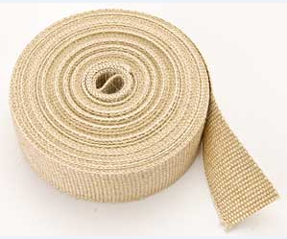

**FIGURE #1**

***Contact Our Service Department With Any Questions***

***CHITTENANGO*** *– phone 800-962-5768 or*

*Daryl Wallace :* [*dwallace@newyorkbussales.com*](mailto:dwallace@newyorkbussales.com)

*Brian Lamaitis :* [*blamaitis@newyorkbussales.com*](mailto:blamaitis@newyorkbussales.com)

***ROCHESTER*** *– phone 800-463-3232 or*

*Gary Chichester:* [*gchichester@newyorkbussales.com*](mailto:gchichester@newyorkbussales.com)

***ALBANY*** *– phone 866-867-1100 or*

*Ben Reiling:* [*breiling@newyorkbussales.com*](mailto:breiling@newyorkbussales.com)

***WARRANTY*** *– 800-962-5768 ext 237*

*Morgan Jenkins:* [*mjenkins@newyorkbussales.com*](mailto:mjenkins@newyorkbussales.com)

**PLEASE ALSO NOTE OUR NEW CUSTOMER SUPPORT REPRESENTATIVES**

***EAST***

*Gary Bigness:* [*gbigness@newyorkbussales.com*](mailto:gbigness@newyorkbussales.com)

*Cell 845-500-3707*

***CENTRAL***

*JJ Richmond:* [*jrichmond@newyorkbussales.com*](mailto:jrichmond@newyorkbussales.com)

*Cell 315-559-3999*

***WEST***

*Mike Panzica:* [*mpanzica@newyorkbussales.com*](mailto:mpanzica@newyorkbussales.com)

*Cell 716-908-3186*

