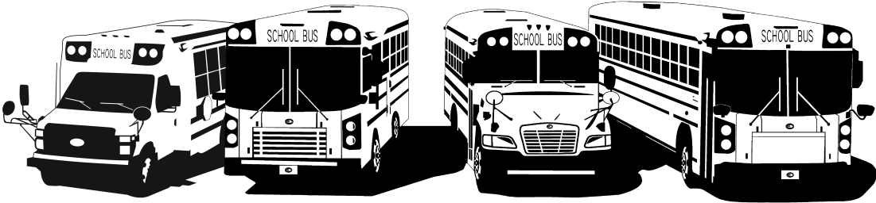
FROM YOUR FRIENDS AT NEW YORK BUS SALES!

GM Fuel Tank Abrasion
Complaint – We are not sure if our fuel tank needs to be replaced
Cause – Something has rubbed into or struck the fuel tank causing an abrasion or gouge in the plastic
Correction – Attached is GM Service Bulletin #6269 for a previous issue where the emergency brake cable rubbed into the plastic tank causing a groove or gouge. Below in figure #1 is the excerpt from the Bulletin as to check using a straight edge and 5/64” drill bit. Photos #1 & #2 show actual fuel tank gouges!
FIGURE #1
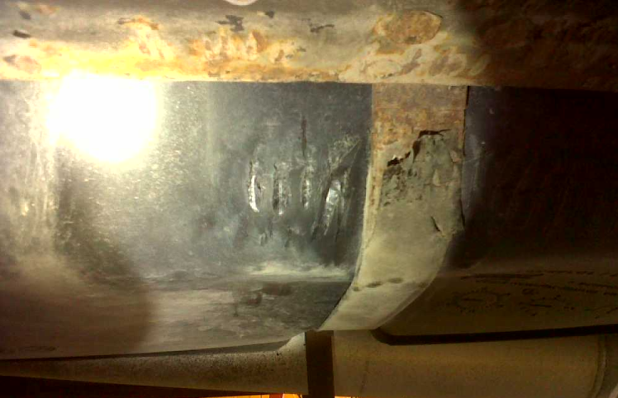
Photo #1 Photo #2
Contact Our Service Department With Any Questions

CHITTENANGO – phone 800-962-5768 or
Daryl Wallace : dwallace@newyorkbussales.com
Brian Lamaitis : blamaitis@newyorkbussales.com
ROCHESTER – phone 800-463-3232 or
Gary Chichester: gchichester@newyorkbussales.com
ALBANY – phone 866-867-1100 or
Ben Reiling: breiling@newyorkbussales.com
Steve Searles: ssearles@newyorkbussales.com
WARRANTY – 800-962-5768 ext 237
Morgan Jenkins: mjenkins@newyorkbussales.com



ALL of our Tech Tips can be found on the New York Bus Sales website at
http://www.newyorkbussales.com/pages/bulletins.cfm
Or at the New York Head Mechanic website at
http://www.nyhma.org/viewforum.php?f=2&start=0

