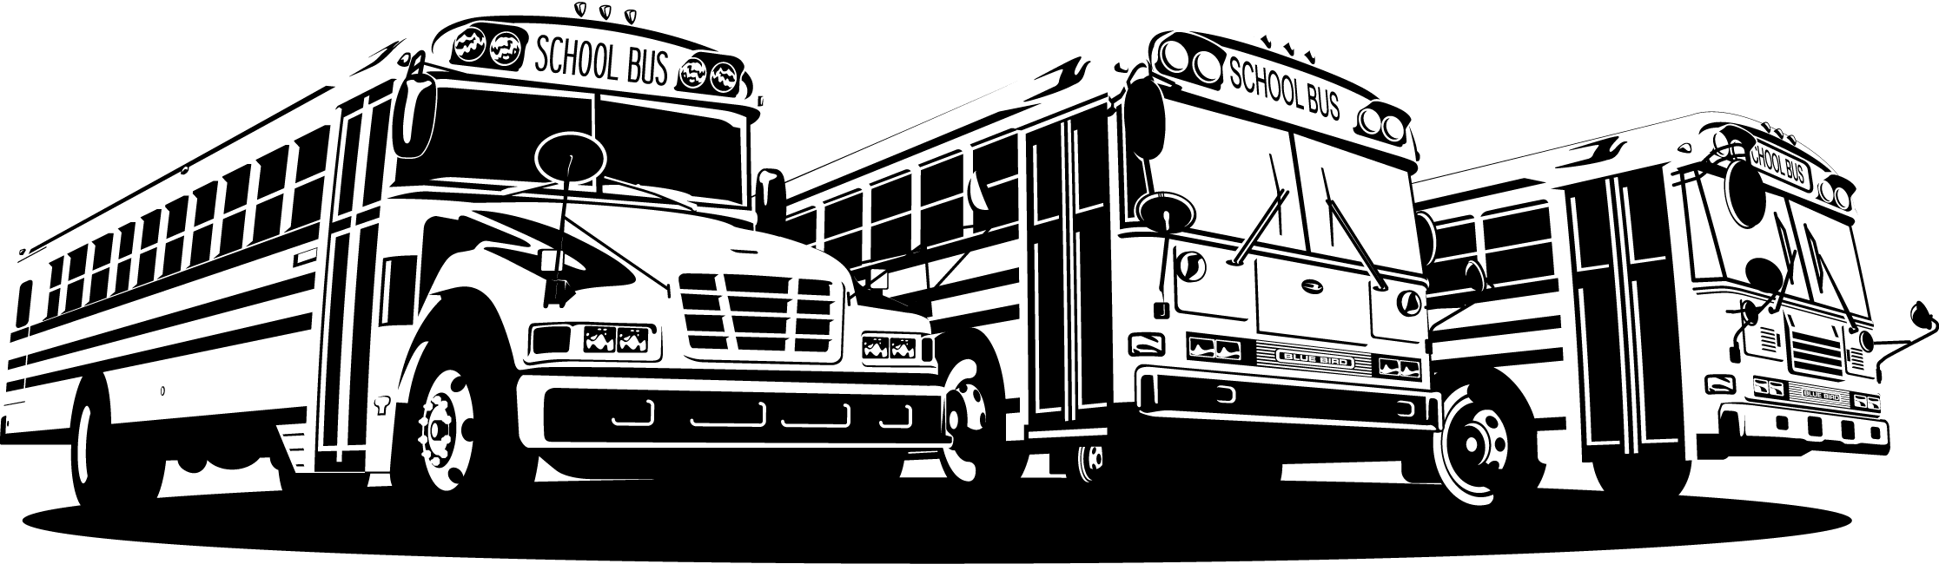
Tech Tip

From your friends at New York Bus Sales
Product Affected-Blue Bird Units w/2010 Cummins

Complaint - We have found that with the northeast road conditions including winter road treatment and where the NOX module and resistor are mounted that issues may exist that can be addressed by remounting the hardware -

Cause - NOX Module and Resistor Mounting

Correction - As you can see in Figure #1, the NOX Module and Resistor are mounted on the outside of the frame rail just before the right rear duals which as shown in this photo has road debris already covering it.
We are recommending that the Module and Resistor be moved to the inside of the frame rail where it is better protected – This can be done using the existing holes and hardware –

We also recommend that the connections be taken apart and inspected …….. as you can see in FIGURES #2 and #3 – There is corrosion already forming as even though these are “weatherpac” connectors the products used to keep the ice and snow from the roads creeps into spots where we do not want it – we are recommending that petroleum jelly or dielectric grease be used in these connections as a preventable measure while moving the Module and Resistor.

Contact Our Service Department With Any Questions

CHITTENANGO – phone 800-962-5768 or
Daryl Wallace : dwallace@newyorkbussales.com
Brian Lamaitis : blamaitis@newyorkbussales.com
ROCHESTER – phone 800-463-3232 or
Gary Chichester: gchichester@newyorkbussales.com
ALBANY – phone 866-867-1100 or
Ben Reiling: breiling@newyorkbussales.com
Steve Searles: ssearles@newyorkbussales.com
WARRANTY – 800-962-5768 ext 237
Morgan Jenkins: mjenkins@newyorkbussales.com


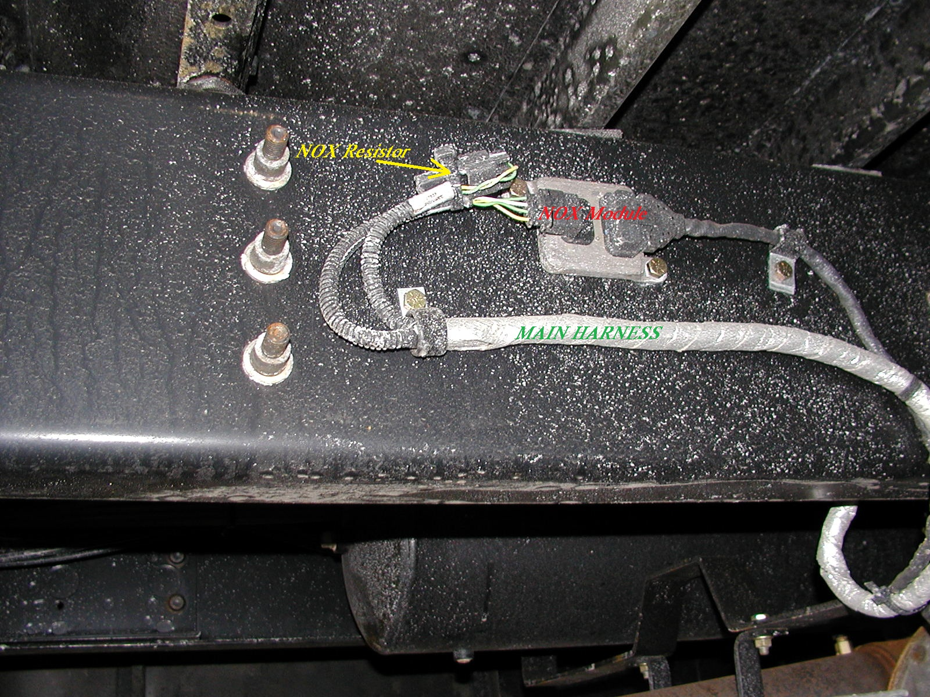
FIGURE #1

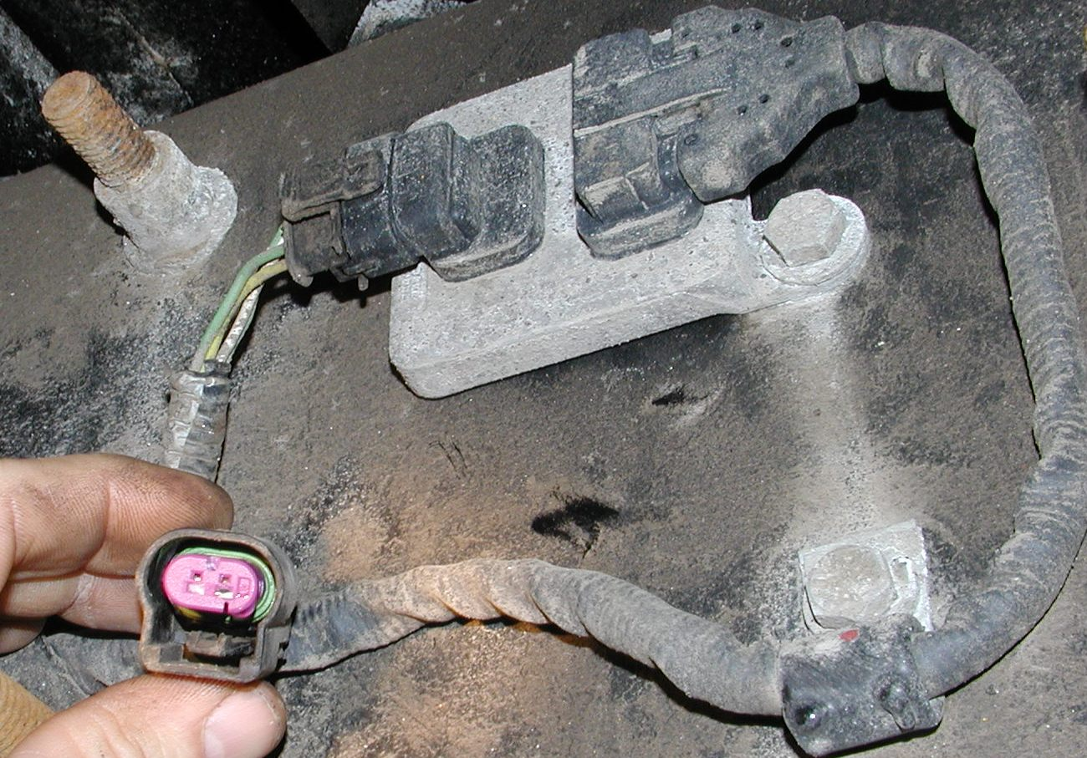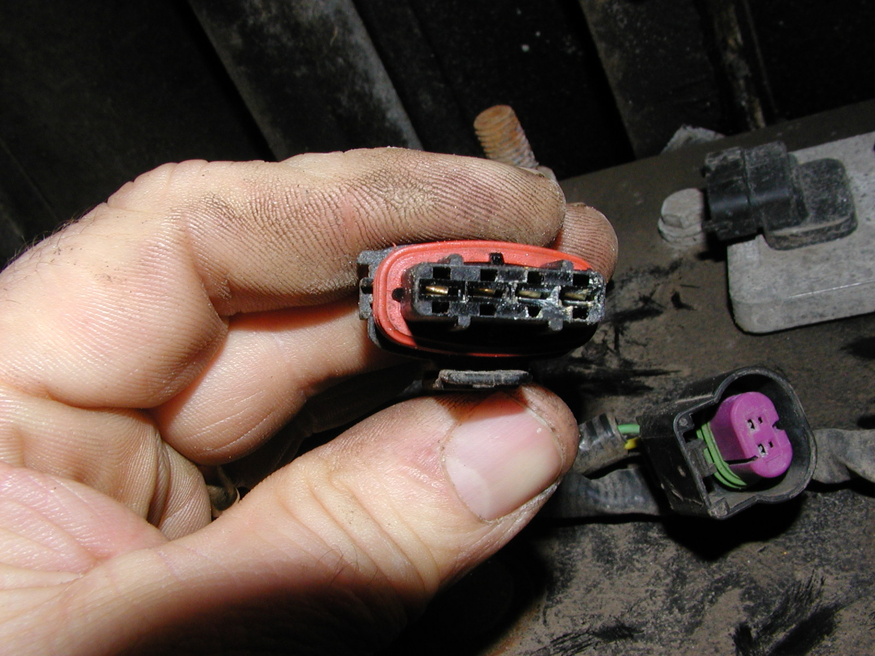
FIGURE #2 FIGURE #3

ALL of our Tech Tips can be found on the New York Bus Sales website at
http://www.newyorkbussales.com/pages/bulletins.cfm
Or at the New York Head Mechanic website at
http://www.nyhma.org/viewforum.php?f=2&start=0

