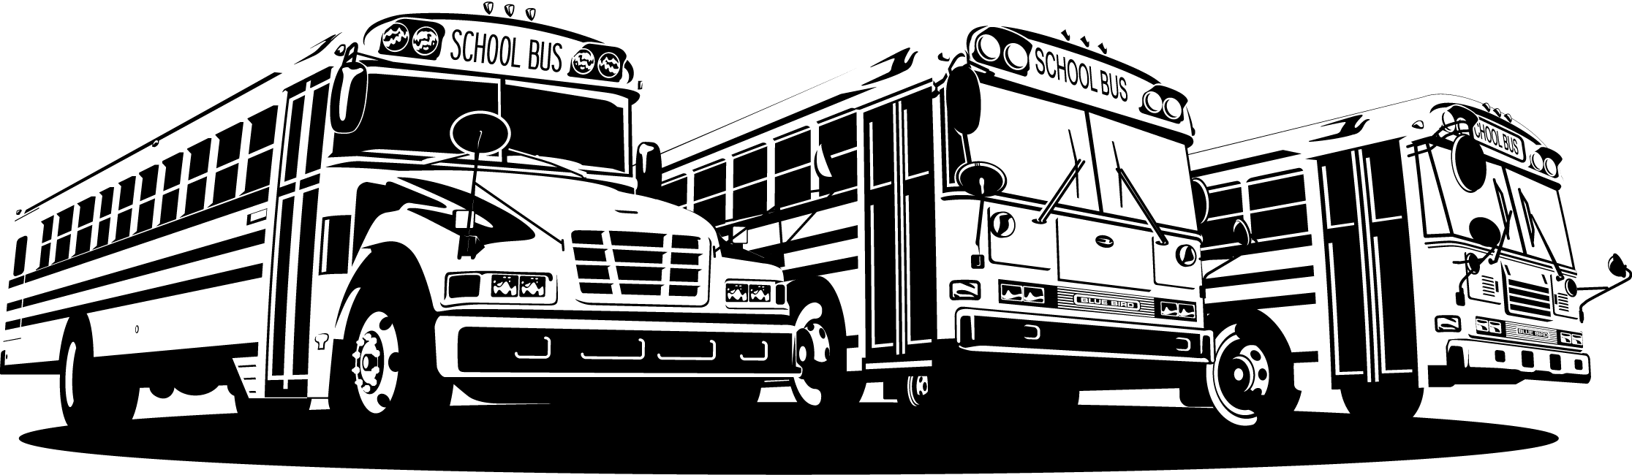
Tech Tip

From your friends at New York Bus Sales
Product Affected-Units with New Emissions and Diesel Engines
Complaint - The exhaust manifold seems to be leaking as there is a black “soot” trail forming but there does not seem to be a leak-

Cause - With the new emissions not producing “soot” as in the past, when the engines are cold the metals “shrink” forming slight gaps where when started the exhaust leaks out and causes these streaks.

Correction - Make sure that you are checking for exhaust leaks with the engine at operating temperature – This way you know that the metals have expanded to their full size. Even with the slightest contraction and expansion when sealing these the manifolds may again leak when cold and then seal when at operating temperature.


Contact Our Service Department With Any Questions

CHITTENANGO – phone 800-962-5768 or
Daryl Wallace : dwallace@newyorkbussales.com
Brian Lamaitis : blamaitis@newyorkbussales.com
ROCHESTER – phone 800-463-3232 or
Gary Chichester: gchichester@newyorkbussales.com
ALBANY – phone 866-867-1100 or
Ben Reiling: breiling@newyorkbussales.com
Steve Searles: ssearles@newyorkbussales.com
WARRANTY – 800-962-5768 ext 237
Morgan Jenkins: mjenkins@newyorkbussales.com
THANKS TO RICH DENNISH FROM
AMERICAN BUS AND COACH FOR POINTING THIS OUT TO US!!!

ALL of our Tech Tips can be found on the New York Bus Sales website at
http://www.newyorkbussales.com/pages/bulletins.cfm
Or at the New York Head Mechanic website at
http://www.nyhma.org/viewforum.php?f=2&start=0

