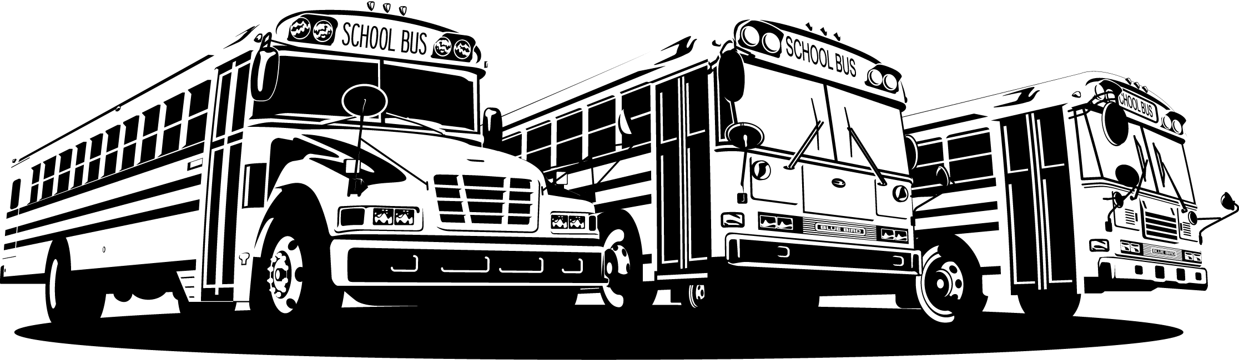
Tech Tip

From your friends at New York Bus Sales
Product Effected – Blue Bird Type C&D

Complaint - The unit appears to have a fuel leak at the tank -

Cause – After looking at the unit and the top of the tank is found to be dry the only other spot found to have an issue is the tank “vent line” – you should check to see which vent is in your tank.
There was a new style vent that was used in production which is pictured in Figure #1, this vent contacts fuel at a lower level than the first production vent which is shown in Figure #2. If you look at the design of the tank, especially those “mid-mounted” in the frame ….. even if the “first-click” method is used in fueling the tank it will allow the tank to take on more fuel as there is a 2-1/2” fuel fill line from the tank to the fuel fill which needs to be filled with fuel before it will “clock off”.
This higher level also causes the tank to allow fuel to be released from the vent line which would appear as a fuel leak.

Correction Once you are sure this is the location of the leak you should pull the vent and inspect. The “new” style vent should be replaced with the “old” style vent.
In changing the vents you are raising the fuel contact point of the vent which if the first click method is used will cause no problems with a vent line leak.

NEW TANK VENT
#00066606

Figure #1
OLD TANK VENT
#01237072

Figure #2
Contact Our Service Department With Any Questions

CHITTENANGO – phone 800-962-5768 or
Daryl Wallace : dwallace@newyorkbussales.com
Brian Lamaitis : blamaitis@newyorkbussales.com

ROCHESTER – phone 800-463-3232 or
Gary Chichester: gchichester@newyorkbussales.com

ALBANY – phone 866-867-1100 or
Ben Reiling: breiling@newyorkbussales.com
Steve Searles: ssearles@newyorkbussales.com

