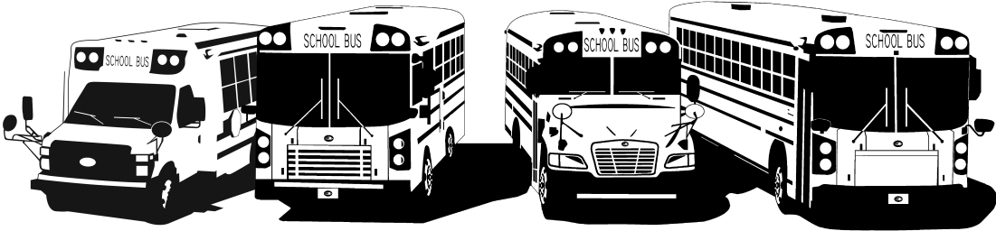
FROM YOUR FRIENDS AT NEW YORK BUS SALES!
Company Update

Employee Appreciation Day and the Dedication of Our Building Expansion
Today our employees enjoyed a brief day of appreciation from a summer filled with hard work and deadlines by gathering at our main facility in Chittenango.
We topped the day off with the dedication of the building expansion (we should be in very soon) to Marlene who has worked very hard and devoted herself to the growth of New York Bus Sales!
The entire staff got to see her christen the project with a bottle of New York’s finest champagne as a tribute to her keeping the New York Bus Sales ship floating forward!
EVERYONE at New York Bus Sales would also like to take a moment to THANK each and everyone of our customers for the support and confidence they have given us in assisting with their transportation needs and we ALL look forward to continuing to work with you all!
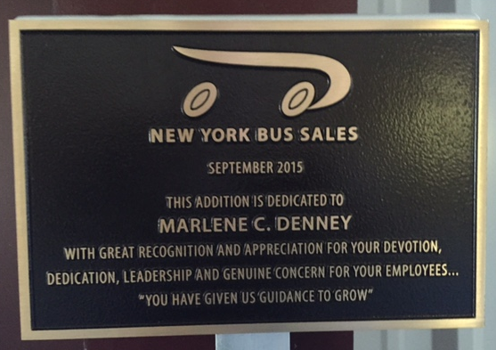

MISSION STATEMENT
The mission statement of New York Bus Sales is to provide safe, dependable transportation vehicles for our customers with courteous and professional service to meet their needs. Understanding our customer's objectives is what guides us toward providing practical and economical solutions to their problems.
VISION STATEMENT
New York Bus Sales seeks to be recognized as the premier transportation dealership in New York State, providing the most reliable products and services in the industry.
VALUES
Our employees are the most valued asset of our company. They are participants with a shared responsibility in fulfilling our mission. We recognize that the safety, quality, motivation and performance of our employees are the key factors in achieving our success. We are committed to the highest standards of ethics and integrity. We are responsible to our customers, our fellow workers and their families and to the communities we live in. Our actions must always reflect the high standards we profess.

